

DATA ORGANIZATION DOCUMENT

**Current Owner:** Niccolò Cappellini

The **purpose** of this document is to show which software applications will be used for the development of the project. There will be defined the standard protocols to follow such as how to handle Data Types and storage, the directory structure, naming convention and how the data is stored.

|  |  |  |
| --- | --- | --- |
| Creation date: 16/10/20 15:15 | **REVISION HISTORY** | Last Modification: 04/11/20 16:59 |
| WHO | WHEN | WHAT |
| Niccolò Cappellini | 16/10/2020 15:15 | Document created |
| Ridiculus Boggarts | 16/10/2020 17:48 | First draft of the document |
| Niccolò Cappellini | 16/10/2020 14:06 | Added Whiteboard link |
| Niccolò Cappellini | 29/10/2020 14:00 | Updated Directory Structure and File Naming Convention |
| Niccolò Cappellini | 04/11/2020 16:59 | Updated font format |

# 

# SOFTWARE LIST

## Organization Software

Google Documents (2020), Discord (V. Stable 69536), Whiteboard1 (V. 20.10)

## Development Software

Github Desktop (V. 2.5.6)

## Editing Software

Photoshop CC 2018, Diagrams.net (13.8.6)

## Environments

Microsoft Windows 10 (1909)

# DATA TYPES & FORMAT

## Text

*.docx, *.pdf  
Font used: Comfortaa

|  |  |  |  |  |
| --- | --- | --- | --- | --- |
| Paragraph Type | Size | Bold | Italic | Underlined |
| Normal text | 11 | no | no | no |
| Title | 18 | yes | no | no |
| Header 1 | 14 | yes | no | no |
| Header 2 | 12 | yes | no | no |
| Header 3 | 11 | yes | no | no |

## Pictures

*.png, *.jpg, *.psd (Photoshop project extension), *.drawio (Diagranms.net project extension)

# DATA STORAGE & ACCESS

The team has a shared Google Drive folder2 for quickly sharing all needed files, whereas all the datas that are going to be used will be stored into a GitHub repository.

## Backup

All files about the project are available on GitHub repository, managed by Edoardo Carrer and a copy of the project is stored in our personal pc.

1<https://wbd.ms/share/v2/aHR0cHM6Ly93aGl0ZWJvYXJkLm1pY3Jvc29mdC5jb20vYXBpL3YxLjAvd2hpdGVib2FyZHMvcmVkZWVtLzFhYWFlZWVlN2YxYjRlYzdiNjA2MTQ2MmZiYzRlNDI3X0JCQTcxNzYyLTEyRTAtNDJFMS1CMzI0LTVCMTMxRjQyNEUzRA==>

2<https://drive.google.com/drive/folders/1dACs3Y-AeNwKUgMVnhSoAerpXY4ZnI4L?usp=sharing>

**DIRECTORY STRUCTURE**

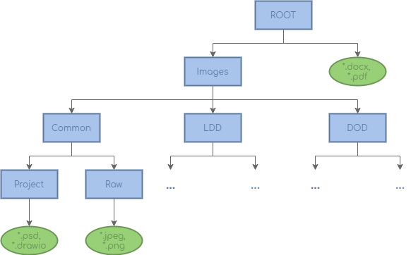

In the root folder is possible to find the work in progress version of the documents and their pdf versions, inside Images. The images are organized in subfolders based on use: in common we find the images used in all documents, in LDD the images used only on LDD and so on. Every type of image must be inside a folder named “Raw”, while each file related to an editing software must be inside a folder named “Project”.

# FILE NAMING CONVENTION

For folders: Camel Case (e.g. FolderName)

For files: Prefix shown in the table then Camel Case followed by extension (e.g. IMG_FileName.ext)

|  |  |  |
| --- | --- | --- |
| Prefix | Type | Format |
| IMG_ | Images | *.jpeg, *.png |
| PRJ_ | Projects | *.psd, *.drawio |